HOSPITAL MANAGEMENT SYSTEM
A PROJECT SUBMITTED TO

BHAKTA KAVI NARSINH MEHTA UNIVERSITY
FOR THE DEGREE
OF
MASTER OF SCIENCE (IT & CA)
Semester-4
IN
COMPUTER SCIENCE
Student Name
Chirag Jitendrakumar Thanki
(Enrollment No.: R24014201004963210031)
Project Guide
Dr. Jyotsna Salet
Associate Professor
Department of Computer Science
Shri V. J. Modha College of Information & Technology - Porbandar

Acknowledgement
• I am sincerely grateful to all those who contributed towards the completion of this Hospital Management System project developed using React.js, Node.js & MongoDB Database. This project would not have been possible without the guidance and support of many individuals.
• First and foremost, I would like to thank Dr. Jyotsna Salet for his invaluable guidance, insightful feedback, and constant encouragement throughout the course of this project. Their expertise and suggestions were instrumental in the successful implementation of this system.
• I would also like to express my gratitude to my peers and fellow classmates who provided constructive feedback and motivation during challenging times. Their input was vital in refining the project's features and improving its functionality.
• It is my great pleasure to represent my project as web app titled “Hospital Management System” which done in semester-4 of MSc (IT & CA), affiliated to BKNMU (Bhakta Kavi Narsinh Mehta University).
• Additionally, I am thankful for the availability of various online resources and forums that offered technical insights and solutions to the issues I encountered during the development process.
• Lastly, I would like to extend my appreciation to my family for their unwavering support and understanding while I dedicated time to this project. Their encouragement helped me stay focused and motivated.

INDEX
Table of Contents
1 Project Profile 1
1.1 Purpose 1
1.1.1 Objectives 1
1.2 Scope 2
1.2.1 Modules of the System 2
2 Objective 3
2.1 Technology Review 3
2.2 Literature Review 5
3 Requirement Analysis 7
3.1 Problem Definition 7
3.2 Process Model 9
3.2.1 Patient Registration 9
3.2.2 Appointment & OPD Management 9
3.2.3 Laboratory & Diagnostic Services 10
3.2.4 Pharmacy Management 10
3.2.5 Billing & Payment 11
3.2.6 Discharge Process 11
3.3 Project Planning 13
4 System Diagram 14
4.1 Data Flow Diagram 14
4.1.1 DFD-Level-0 14
4.1.2 DFD-Level-1 15
4.2 E-R (Entity-Relationship) Diagram 16
4.3 Use-Case Diagram 17
5 Data Dictionary 18
5.1 Tables 18
6 User Interface (Frontend) 21
6.1 Dashboard 21
6.2 Patient Registration 22
6.3 Dashboard Menus 24
6.4 Laboratory 25
6.5 Departments 26
6.6 Bed Information 27
6.7 Employee Information 28
6.8 OPD - Outpatient Department Registration 29
6.9 Patient Insurance 31
6.10 Inventory Management 32
6.11 Pharmacy Support 33
6.12 Stock Report 34
7 Server-Side (Backend) 35
7.1 Server.js 35
7.2 app.js: 38
7.3 login.js: 42
7.4 index.html: 48
7.5 package.json 58
7.6 inbox.js 59
7.7 dashboard.js 71
8 Database: 112
9 Advantages 121
10 Limitations 123
11 Future Enhancements 126
12 Conclusion 129
13 Bibliography 131
14 References 133

Project Profile

Purpose

Hospital Management System (HMS) is a software application designed to automate and manage the day-to-day operations of a hospital. It integrates various departments such as registration, appointments, billing, pharmacy, laboratory, and patient records into a single centralized system. The system improves efficiency, reduces paperwork, minimizes errors, and ensures quick access to accurate patient and hospital data.

Objectives
- To computerize hospital administrative and clinical processes
- To maintain centralized and secure patient records
- To streamline appointment scheduling and doctor management
- To improve billing, pharmacy, and laboratory operations
- To enhance overall hospital efficiency and patient care

Scope
The Hospital Management System(HMS) covers:
- Patient registration and record management
- Doctor and staff management
- Appointment scheduling
- Billing and payment processing
- Pharmacy and inventory management
- Laboratory test management
- Report generation and data analytics
The system can be used by hospitals, clinics, and diagnostic centers of any size.

Modules of the System
- Patient Management Module – Registration, medical history, treatment details
- Doctor Management Module – Doctor profiles, schedules, and specialization
- Appointment Module – Online and offline appointment booking
- Billing Module – Invoices, payments, and insurance details
- Pharmacy Module – Medicine stock, sales, and expiry tracking
- Laboratory Module – Test requests, results, and reports
- Admin Module – User management, system settings, and reports

Objective

Technology Review
The Hospital Management System is built using modern web development technologies to ensure scalability, performance, and ease of maintenance. The backend is developed using Node.js, a powerful runtime environment that allows developers to run JavaScript on the server side.

Node.js is widely chosen for real-time applications due to its event-driven, non-blocking I/O model, which makes it lightweight and efficient. With Node.js, the system can handle multiple requests simultaneously, making it suitable for a hms management system where users perform frequent operations such as creating, updating, and deleting.

MongoDB is an open-source non-relational database management system widely used for storing, managing, and retrieving unstructured data efficiently. Instead of tables and rows, it stores data as JSON-like documents, making it easy to work with modern applications. MongoDB supports dynamic schemas, so fields can vary between documents.

MongoDB provides high performance, reliability, and scalability, along with features such as data integrity, transaction support, indexing, and security mechanisms. Its compatibility with multiple programming languages and operating systems enables seamless integration with web and software applications. Due to its flexibility, ease of use, and cost-effectiveness, MongoDB is commonly adopted in web development, data-driven systems, and cloud-based solutions.

The system primarily implements CRUD (Create, Read, Update, Delete) operations, which are the backbone of any data-driven application. CRUD ensures that users can efficiently manage their hms by adding new entries, retrieving existing data, modifying hms details, and removing completed or unnecessary records.

These operations are implemented using RESTful APIs in Node.js, providing a structured way to interact with the database. Additionally, frameworks and libraries such as Express.js are commonly integrated to simplify server-side development, improve routing, and manage middleware effectively.

To enhance usability, the system may incorporate front-end technologies like HTML, CSS, and JavaScript, or modern frameworks such as React or Angular, depending on the design requirements. This ensures a user-friendly interface where it can be managed seamlessly.

Literature Review

HMS Hospital Management Systems have been widely studied and developed in both academic and industrial contexts. In today’s fast-paced environment, effective hms organization is crucial for personal productivity as well as collaborative teamwork.

Traditional methods, such as paper-based planners and spreadsheets, often fail to provide real-time synchronization, accessibility, and scalability. As a result, digital solutions leveraging web and cloud technologies have gained popularity.

Research in hms management systems emphasizes the importance of intuitive interfaces, real-time synchronization, and flexible data handling. Several existing systems, such as Trello, Asana, and Microsoft To Do, highlight features like drag-and-drop hms organization, reminders, and team collaboration.

However, many of these platforms are either too complex for small-scale use or restricted by subscription-based models. This creates opportunities for building customized systems tailored to specific needs.

Studies also indicate that integrating hms management systems with cloud-based databases improves accessibility and data consistency across devices. MongoDB’s document-based storage model has been noted for its adaptability in managing unstructured or semi-structured data, which is common in hms management applications.

Node.js, due to its asynchronous nature, has been widely discussed in research for building real-time collaborative tools, including chat systems, project trackers, and managers.

By combining Node.js and MongoDB, Hms aligns with contemporary research and best practices in software engineering. It offers a balance of efficiency, scalability, and user-friendliness. The literature supports the use of CRUD-based architectures for managing core functionalities, ensuring that the users can perform essential hms operations reliably and efficiently with ease.

Requirement Analysis

Problem Definition

Hospitals are complex organizations that involve multiple departments such as registration, outpatient services, inpatient care, laboratories, pharmacies, billing, and administration.
In many hospitals, especially small and medium-sized healthcare institutions, these activities are still managed using manual or semi-computerized systems. This leads to inefficiencies, data redundancy, delays, errors in record keeping, and difficulty in accessing accurate patient information when needed.
The traditional manual hospital management process relies heavily on paper-based records for patient registration, medical history, prescriptions, laboratory reports, and billing details. Maintaining these records is time-consuming and prone to human errors such as misplacement of files, duplication of data, incorrect billing, and loss of critical medical information.
As the number of patients increases, managing appointments, tracking patient history, coordinating between departments, and generating reports becomes increasingly difficult. Another major issue is the lack of integration between hospital departments.
Doctors, laboratory staff, pharmacists, and billing personnel often work in isolation, resulting in poor communication and delays in patient care.

For example, laboratory reports may not be available on time, prescriptions may be misread, and billing calculations may be inaccurate due to missing or inconsistent data. This negatively affects the quality of healthcare services and patient satisfaction.
Additionally, manual systems make it difficult to generate real-time reports for hospital management, such as bed availability, medicine stock levels, revenue details, and patient statistics. This limits effective decision-making, planning, and resource utilization. Security and confidentiality of patient data are also major concerns, as paper records can be easily accessed, damaged, or lost.
To overcome these problems, there is a need for an efficient, reliable, and integrated Hospital Management System. The proposed system aims to automate and manage all hospital-related activities through a centralized computerized platform. It will ensure accurate data storage, easy retrieval of patient information, seamless communication between departments, reduced workload, improved operational efficiency, and enhanced quality of patient care while maintaining data security and confidentiality.

Process Model

A process model shows how data and activities flow through the hospital system—from a patient walking in to discharge and billing. It focuses on who does what, in what order, and how information moves between departments.
The process model of HMS can be divided into several key stages:

Patient Registration
Actors: Patient, Receptionist
Process:
- Patient provides personal details
- System generates Patient ID
- Records stored in patient database
Outputs: Patient record, registration confirmation

Appointment & OPD Management
Actors: Patient, Doctor, System
Process:
- Appointment scheduled
- Doctor views patient history
- Consultation details entered
Outputs: Diagnosis, prescriptions, test requests

Laboratory & Diagnostic Services
Actors: Lab Technician, System
Process:
- Doctor orders lab tests
- Samples collected
- Test results uploaded to system
Outputs: Lab reports available to doctor & patient

Pharmacy Management
Actors: Pharmacist, System
Process:
- Doctor sends prescription
- Medicines issued
- Inventory updated automatically
Outputs: Medicine bill, stock update

Billing & Payment
Actors: Billing Staff, Patient
Process:
- Charges calculated (consultation, lab, room, pharmacy)
- Invoice generated
- Payment processed (cash/card/insurance)
Outputs: Final bill, payment receipt

Discharge Process
Actors: Doctor, Nurse, Billing Department
Process:
- Discharge summary prepared
- Final bill cleared
- Patient discharged
Outputs: Discharge summary, medical history archived

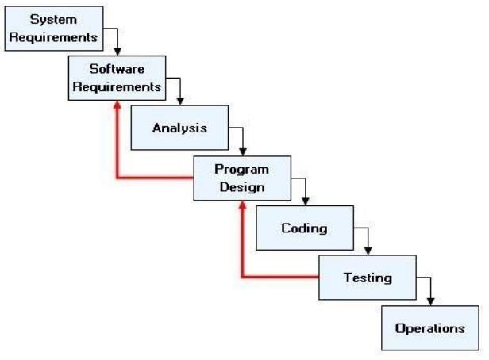

Project Planning

Phase | Timeline
Requirement Analysis | Week 1
Design & Mockups | Week 2
Development | Weeks 3 - 6
Testing | Weeks 7 - 8
Deployment | Week 9
Documentation | Week 10

System Diagram

Data Flow Diagram

DFD-Level-0

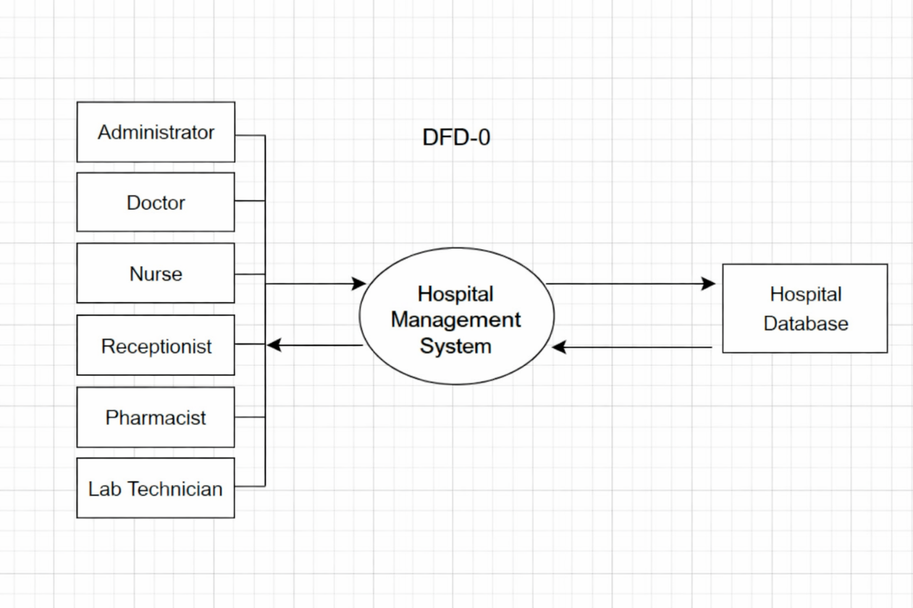

DFD-Level-1

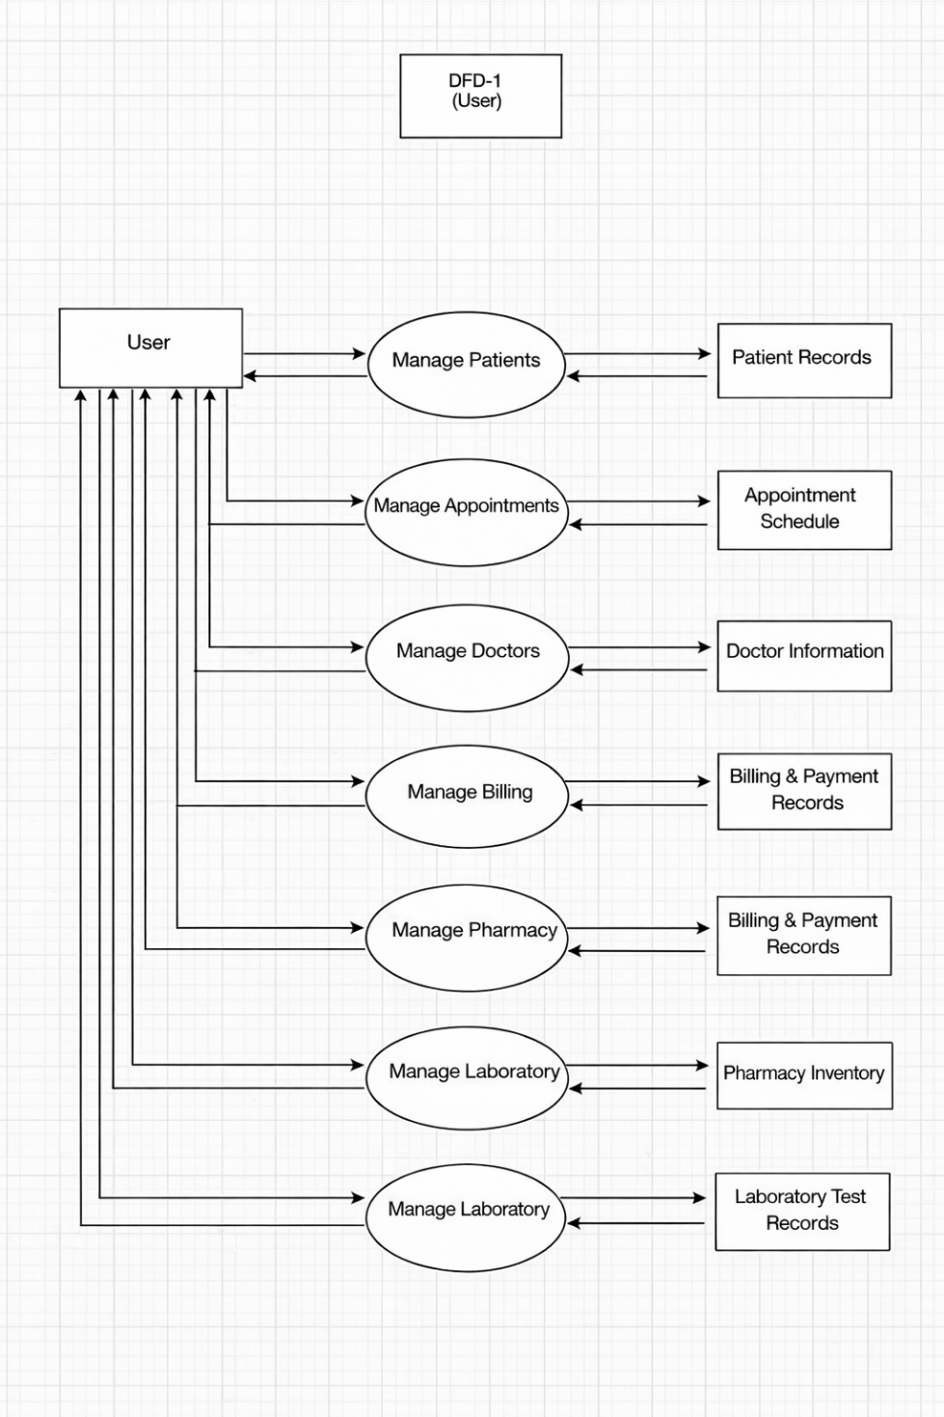

E-R (Entity-Relationship) Diagram

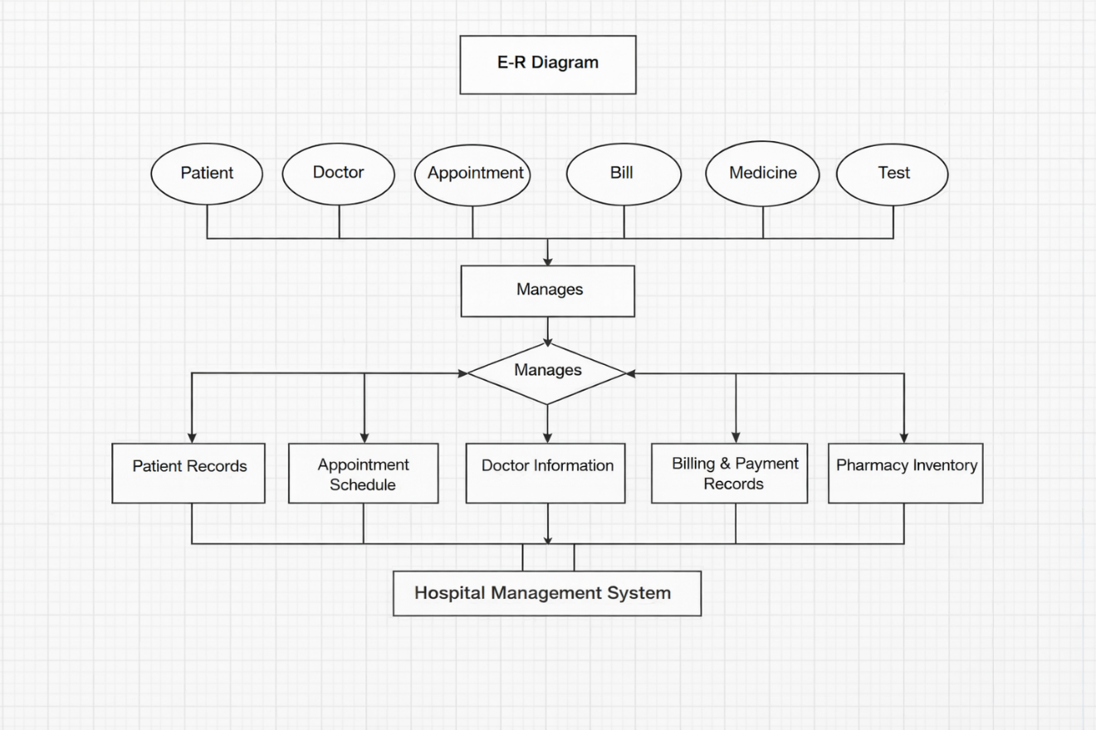

Use-Case Diagram

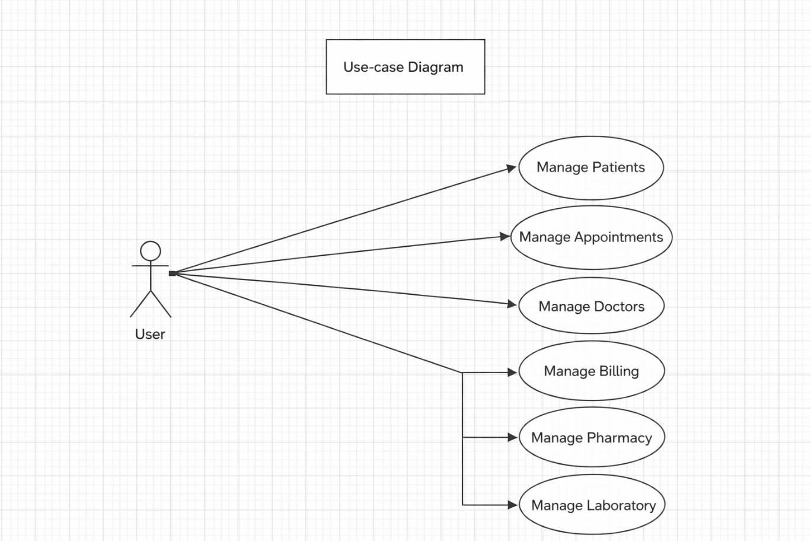

Data Dictionary

Tables

Table-1: Patient Table
Field | Data Type
patient_id | INT
first_name | VARCHAR
last_name | VARCHAR
gender | VARCHAR
date_of_birth | VARCHAR
phone | VARCHAR
address | VARCHAR

Table-2: Doctor Table
Field | Data Type
doctor_id | INT
doctor_name | VARCHAR
specialization | VARCHAR
phone | VARCHAR
email | VARCHAR
department | VARCHAR

Table-3: Appointment Table
Field | Data Type
appointment_id | INT
patient_id | VARCHAR
doctor_id | VARCHAR
appointment_date | DATE
appointment_time | TIME
status | VARCHAR

Table-4: Billing Table
Field | Data Type
bill_id | INT
patient_id | INT
appointment_id | INT
total_amount | DECIMAL
payment_status | VARCHAR
payment_date | DATE

Table-5: Pharmacy Table
Field | Data Type
medicine_id | INT
medicine_name | VARCHAR
quantity | INT
price | DECIMAL
expiry_date | DATE

Table-6: Laboratory Test Table
Field | Data Type
test_id | INT
test_name | VARCHAR
test_cost | DECIMAL

User Interface (Frontend)

Dashboard

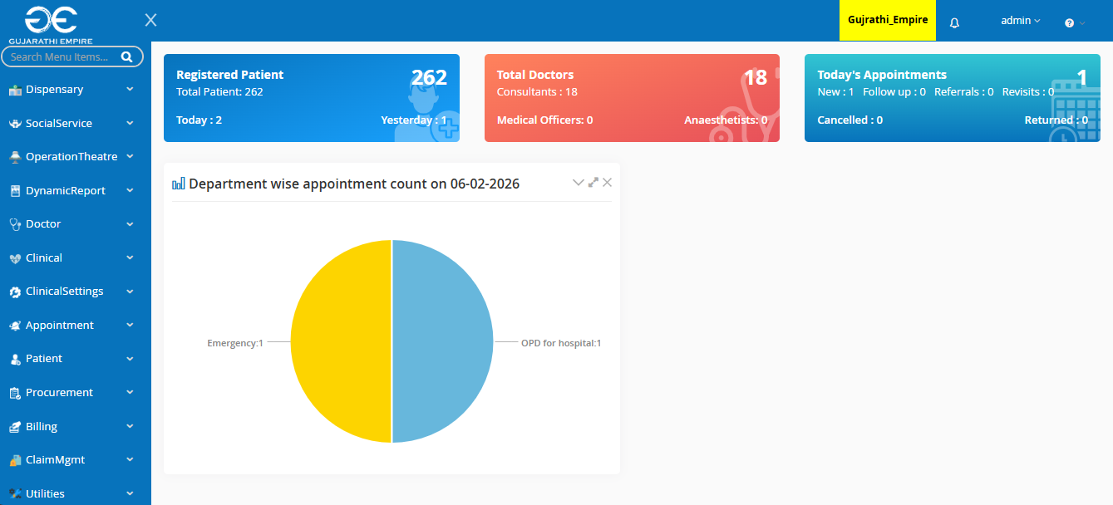

- The Dashboard is the main landing page of the Hospital Management System after user login. It provides a quick overview of hospital activities and helps users access important modules efficiently.

- A dashboard is a visual user interface that provides a centralized, real-time, or near real-time, overview of key performance indicators (KPIs), metrics, and critical data points from various sources.

Patient Registration

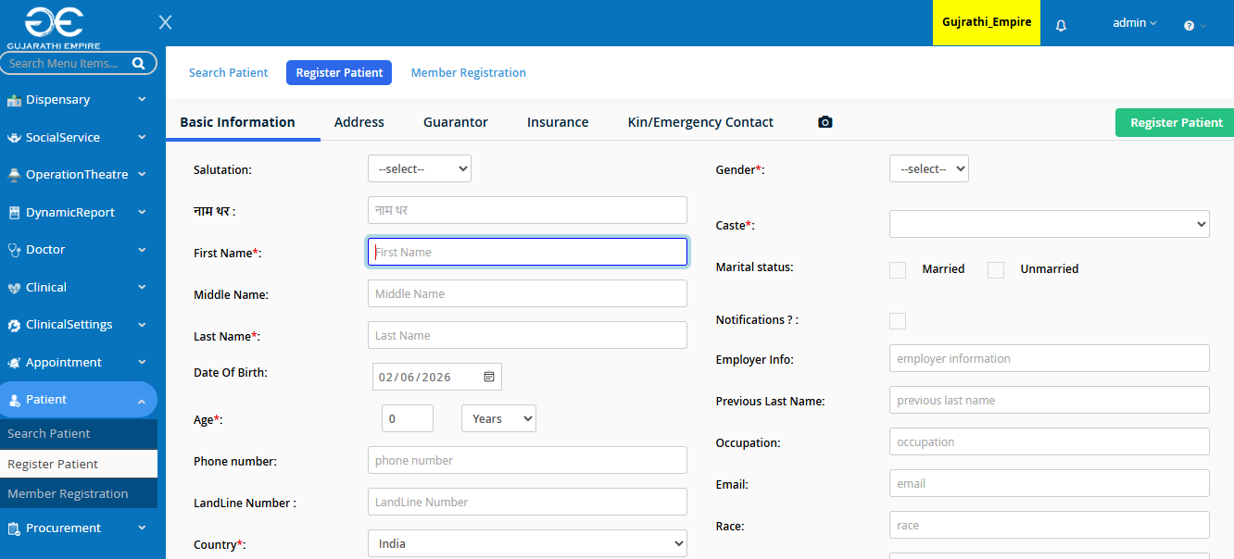

- Patient Registration is the first and most important module of the Hospital Management System. It is used to record and store patient details digitally when a patient visits the hospital for the first time.

- Patient Registration is the module that records patient details, generates a unique patient ID, and stores information digitally for future medical reference.

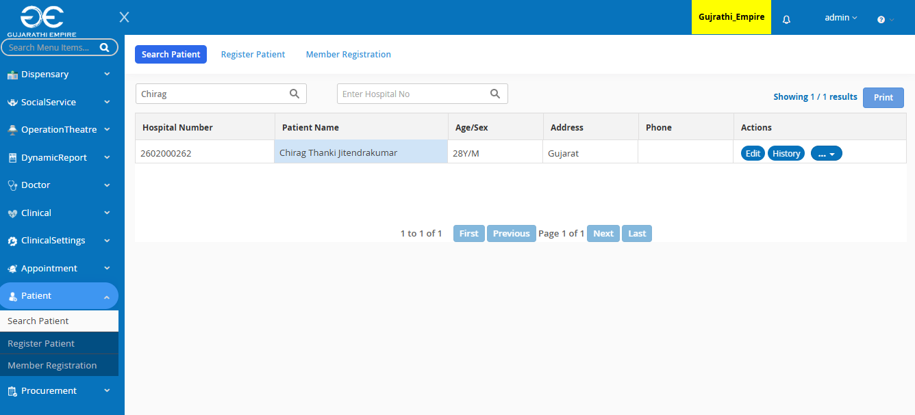

- Features of Patient Registration Module
  - Fast and user-friendly interface
  - Avoids duplicate patient records
  - Supports search and update of patient details
  - Ensures data accuracy and security
  - Role-based access control

Dashboard Menus

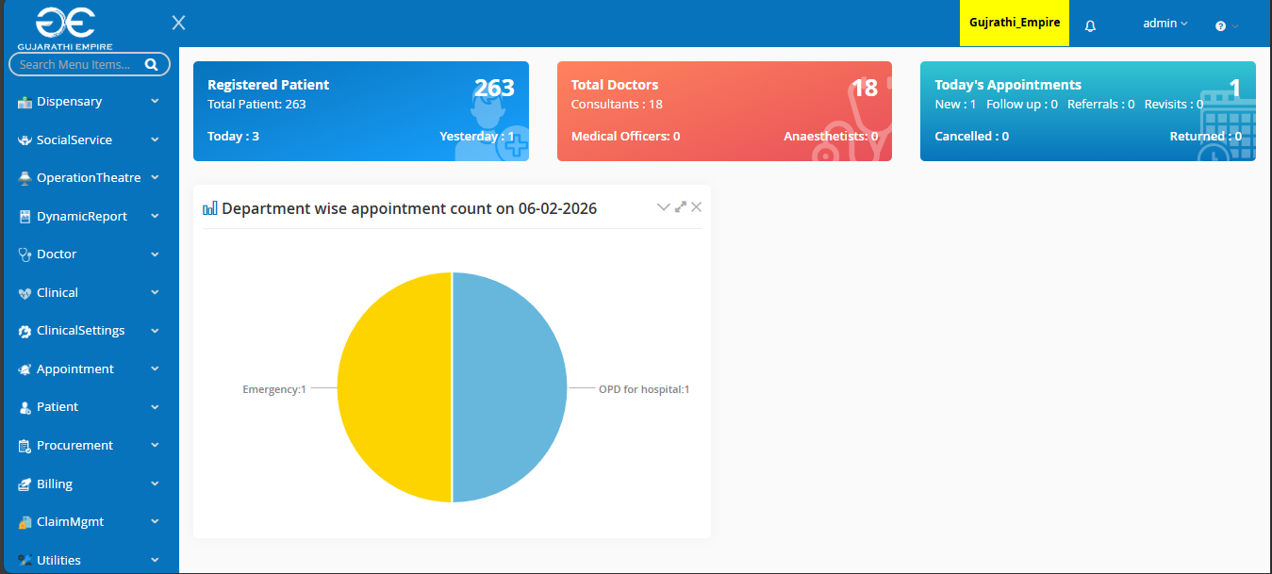

- Dashboard menus shows different menus in this Hospital Management System (HMS) like:
  - Dispensary
  - Operation Theatre
  - Doctor
  - Clinical
  - Appointment
  - Patient
  - Billing
  - Procurement
  - Claim Management
  - Inventory Management

Laboratory

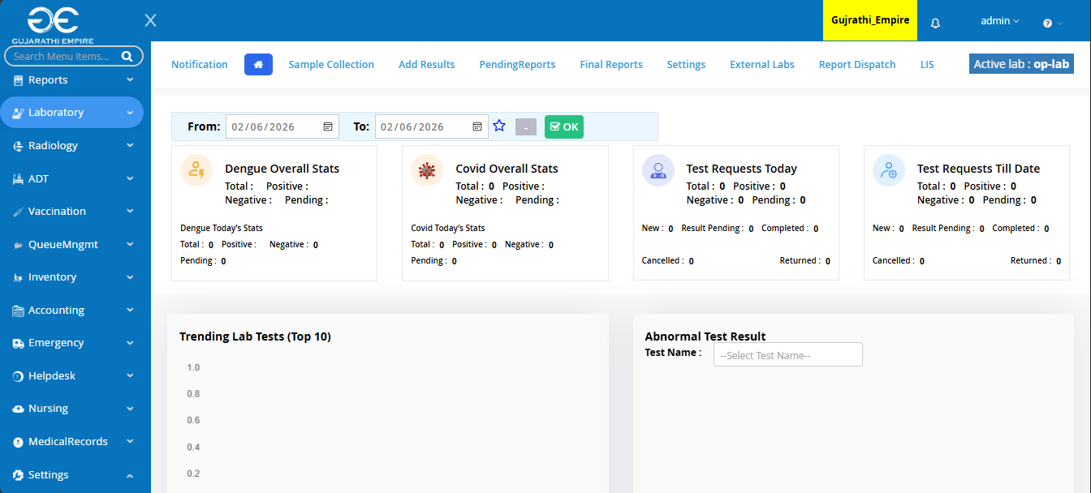

- This tab shows different laboratory related services like
  - Dengue Statistics
  - Test Requests
  - Doctor orders lab tests
  - Samples collected
  - Test results uploaded to system

Departments

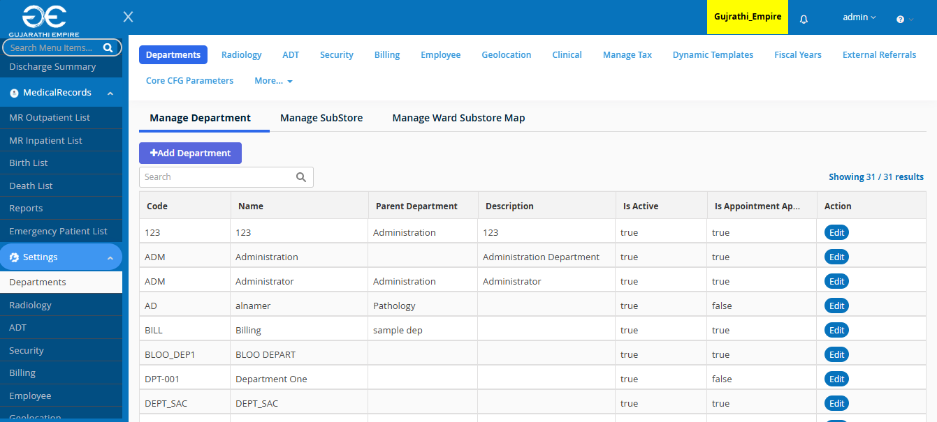

- Shows different departments like:
  - Radiology
  - Admit & Discharge Transfer (ADT)
  - Security
  - Employee
  - Billing
  - Clinical

Bed Information

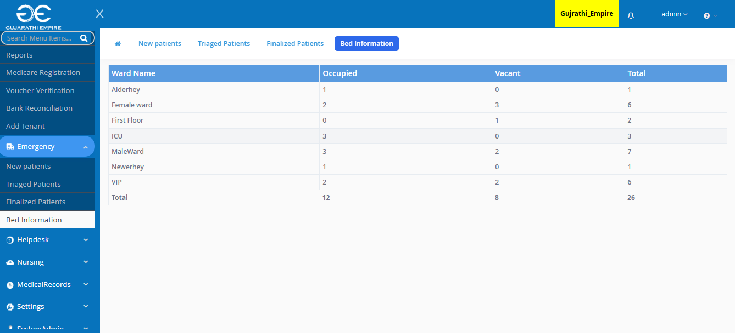

- Shows Information Regarding Beds:
  - Bed Availability
  - Ward detail
  - No. of beds occupied
  - No. of beds vacant
  - Total no. of beds

Employee Information

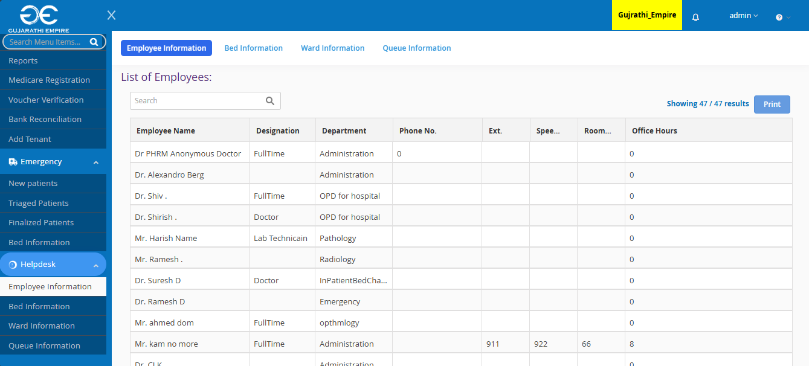

- The Employee Information tab is used to store, manage, and maintain information of all hospital staff in the system.

- It helps the administration manage employees efficiently and ensures proper role-based access

OPD - Outpatient Department Registration

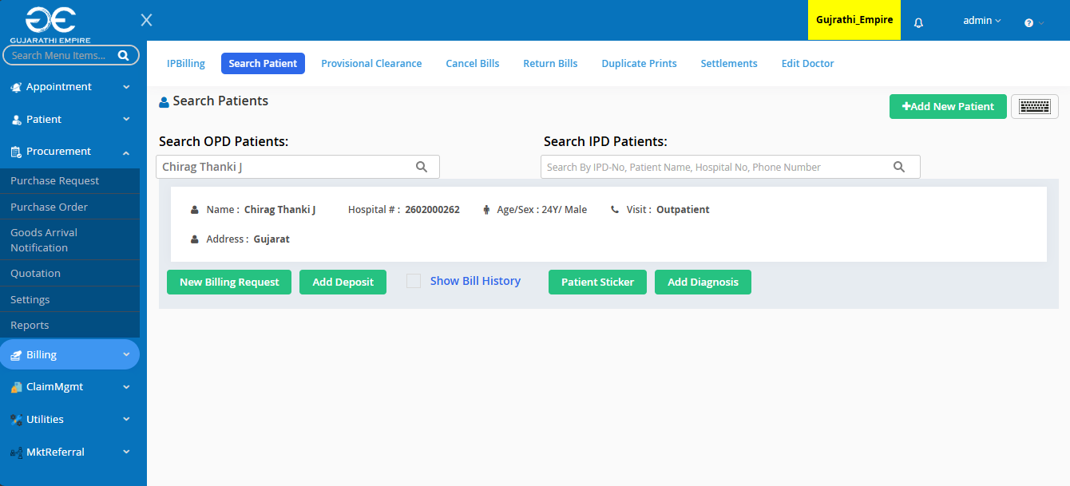

- OPD (Outpatient Department) Information manages details of patients who visit the hospital for consultation and treatment without being admitted.

- This module records each outpatient visit and supports smooth doctor–patient interaction.

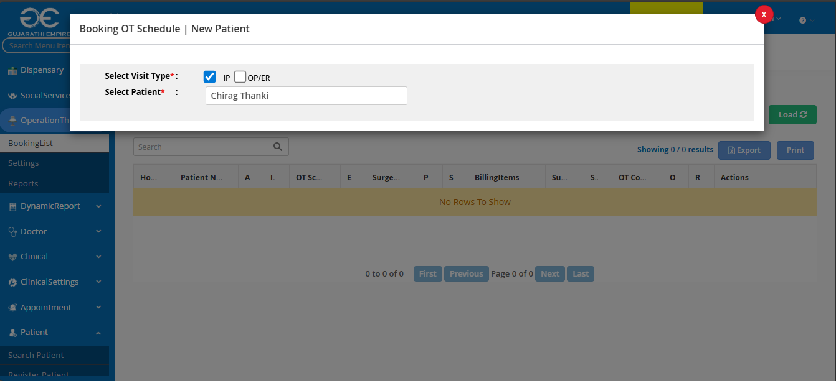

- Gives information about Operation Theatre booking and patient details like name and reason for the operation.

- OPD Information manages outpatient visits by recording consultation details, diagnosis, prescriptions, and lab tests without patient admission.

Patient Insurance

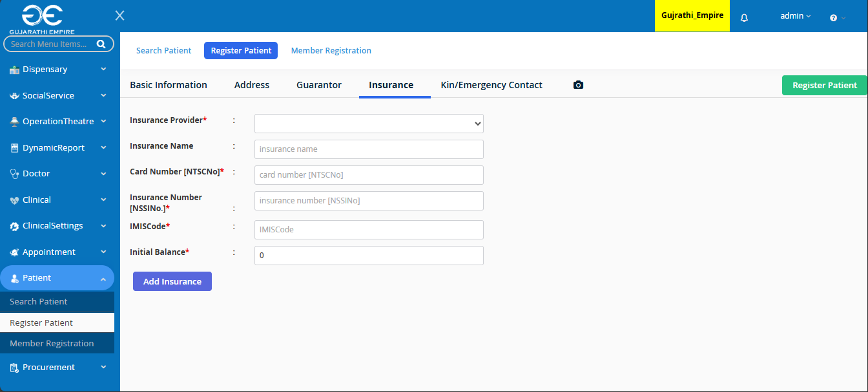

- The Patient Insurance module is used to record, manage, and process insurance details of patients who are covered under health insurance schemes.

- It helps the hospital handle cashless treatment and insurance claims efficiently.

- Store patient insurance information securely

- Simplify billing and claim processing

- Support cashless and insured treatments

Inventory Management

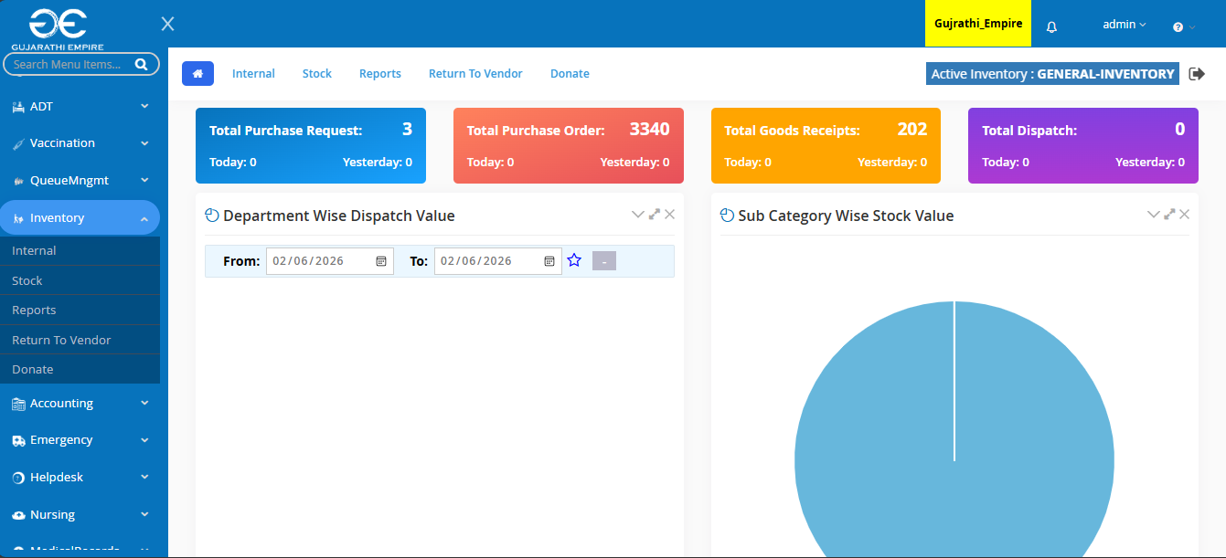

- The Inventory Management module is used to track, control, and manage hospital stock such as medicines, medical equipment, surgical items, and consumables.

- It ensures that required items are always available and prevents shortages or wastage.

- Inventory Management tracks hospital stock, monitors usage and expiry, and ensures timely availability of medical supplies.

Pharmacy Support

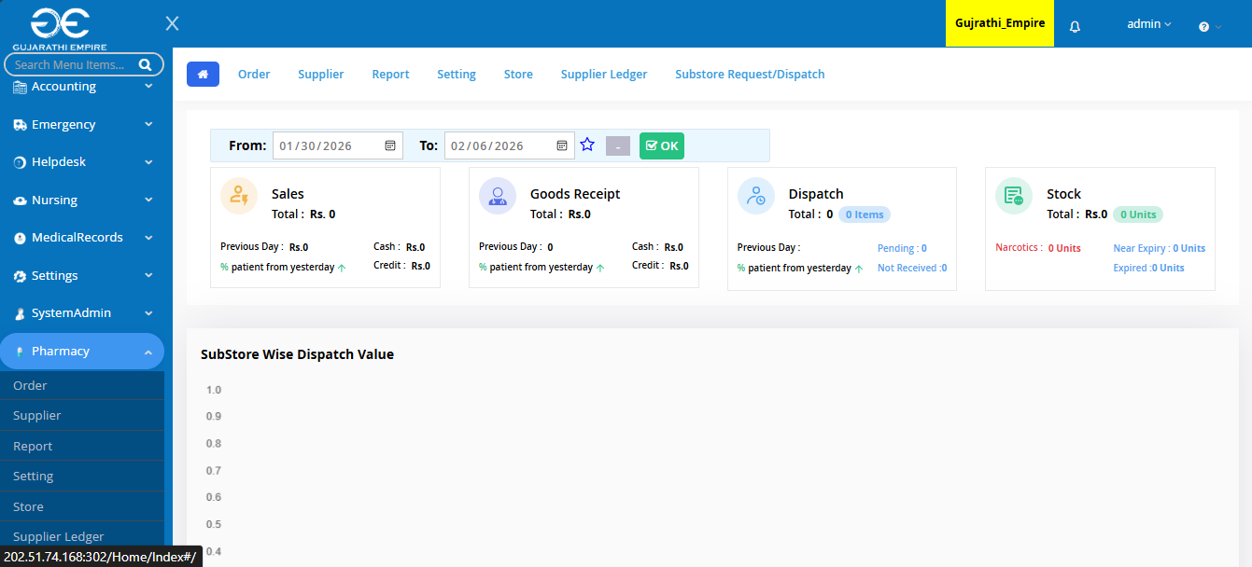

- The Pharmacy Support module manages the dispensing of medicines, maintains medicine inventory, and ensures accurate billing based on doctor prescriptions.

- It plays a vital role in patient treatment and hospital operations.

Stock Report

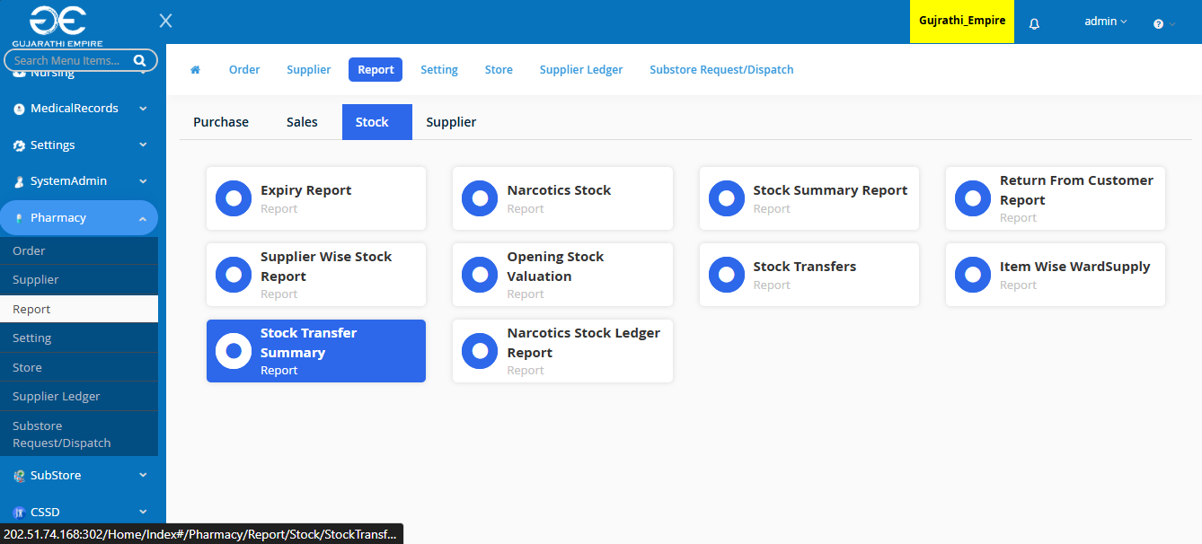

- The Stock Report provides a detailed summary of all inventory items available in the hospital, especially medicines and medical supplies.

- It helps administrators and pharmacy staff monitor stock levels and make timely purchase decisions.

Server-Side (Backend)

Server.js

const express = require("express");
const mongoose = require("mongoose");
const bodyParser = require("body-parser");
const Hms = require("./models/Hms");

const app = express();

app.use(bodyParser.urlencoded({ extended: true }));
app.set("view engine", "ejs");
app.use(express.urlencoded({ extended: true }));

mongoose.connect("mongodb://127.0.0.1:27017/hms", {
useNewUrlParser: true,
useUnifiedTopology: true,
});

// Routes
app.get("/", async (req, res) => {
const hms = await hms.find();
res.render("index", { hms });
});

app.post("/add", async (req, res) => {
const new hms = new hms({ hms: req.body.hms });
await new hms.save();
res.redirect("/");
});

app.post("/update/:id", async (req, res) => {
const { hms } = req.body;
await Hms.findByIdAndUpdate(req.params.id, { hms: hms });
res.redirect("/");
});

app.post("/delete/:id", async (req, res) => {
await Hms.findByIdAndDelete(req.params.id);
res.redirect("/");
});
app.post("/toggle/:id", async (req, res) => {
const hms = await Hms.findById(req.params.id);
hms.completed = !hms.completed;
await hms.save();
res.redirect("/");
});

app.js:

(function () {
'use strict';
var isOn = window.location.hostname === 'blueimp.io',
url = isOn ? '//jquery-file-upload.appspot.com/' : 'server/js/';

angular.module('demo', [
'blueimp.fileupload'
])
.config([
'$httpProvider', 'fileUploadProvider',
function ($httpProvider, fileUploadProvider) {
delete $httpProvider.defaults.headers.common['X-Requested-With'];
fileUploadProvider.defaults.redirect = window.location.href.replace(
/\/[^\/]*$/,
'/cors/result.html?%s'
);
if (isOn) {
// Demo settings:
angular.extend(fileUploadProvider.defaults, {
// Enable image resizing, except for Android and Opera,
// which actually support image resizing, but fail to
// send Blob objects via XHR requests:
disableImageResize: /Android(?!.*Chrome)|Opera/
.test(window.navigator.userAgent),
maxFileSize: 999000,
acceptFileTypes: /(\.|\/)(gif|jpe?g|png)$/i
});
}
}
])

.controller('DemoFileUploadController', [
'$scope', '$http', '$filter', '$window',
function ($scope, $http) {
$scope.options = {
url: url
};

if (!isOn) {
$scope.loadingFiles = true;
$http.get(url)
.then(
function (response) {
$scope.loadingFiles = false;
$scope.queue = response.data.files || [];
},

function () {
$scope.loadingFiles = false;
}
);

}
}
])
.controller('FileDestroyController', [
'$scope', '$http',
function ($scope, $http) {
var file = $scope.file,
state;

if (file.url) {
file.$state = function () {
return state;
};

file.$destroy = function () {
state = 'pending';
return $http({
url: file.deleteUrl,
method: file.deleteType

}).then(
function () {
state = 'resolved';
$scope.clear(file);
},
function () {
state = 'rejected';
}
);
};

} else if (!file.$cancel && !file._index) {
file.$cancel = function () {
$scope.clear(file);
};

login.js:

var usrJson = { user: 'chirag', pwd: 'chirag' };

$(document).ready(function () {
$('#login').show().animate({ opacity: 1 }, 2000);
$('.logo').show().animate({ opacity: 1, top: '40%' }, 800, function ()
{
$('.logo').show().delay(1200).animate({ opacity: 1, top: '12%' }, 300, function ()
{
$('.formLogin').animate({ opacity: 1, left: '0' }, 300);
$('.userbox').animate({ opacity: 0 }, 200).hide();
});

})
$(".on_off_checkbox").iphoneStyle();
$('.tip a ').tipsy({ gravity: 'sw' });
$('.tip input').tipsy({ trigger: 'focus', gravity: 'w' });
});

$('.userload').click(function (e) {
$('.formLogin').animate({ opacity: 1, left: '0' }, 300);
$('.userbox').animate({ opacity: 0 }, 200, function () {
$('.userbox').hide();
});
});

$('#but_logins').click(function (e) {

if (document.formLogin.username.value == "" || document.formLogin.password.value == "") {
showError("Please Input Username / Password");
$('.inner').jrumble({ x: 4, y: 0, rotation: 0 });
$('.inner').trigger('startRumble');
setTimeout('$(".inner").trigger("stopRumble")', 500);
setTimeout('hideTop()', 5000);
return false;
}

else {
var curUsr = document.formLogin.username.value;
var curPwd = document.formLogin.password.value;
return true;

if (curUsr != usrJson.user || curPwd != usrJson.pwd) {
showError("Invalid Username / Password");
$('.inner').jrumble({ x: 4, y: 0, rotation: 0 });
$('.inner').trigger('startRumble');
setTimeout('$(".inner").trigger("stopRumble")', 500);
setTimeout('hideTop()', 5000);
return false;
}
}

hideTop();
loading('Checking', 1);
setTimeout("unloading()", 2000);
setTimeout("Login()", 2500);
});
function Login()
{
$("#login").animate({ opacity: 1, top: '49%' }, 200, function () {
$('.userbox').show().animate({ opacity: 1 }, 500);
$("#login").animate({ opacity: 0, top: '60%' }, 500, function () {
$(this).fadeOut(200, function () {
$(".text_success").slideDown();
$("#successLogin").animate({ opacity: 1, height: "200px" }, 500);
});
})
})
setTimeout("window.location.href='dashboard.html'", 3000);
}

$('#alertMessage').click(function () {
hideTop();
});

function showError(str)
{
$('#alertMessage').addClass('error').html(str).stop(true, true).show().animate({ opacity: 1, right: '10' }, 500);
if (document.formLogin.username.value == "")
{
$('#username_id').addClass('text-error').html(str).stop(true, true).show().animate({ opacity: 1, right: '10' }, 500);
}
if (document.formLogin.password.value == "") {
$('#password').addClass('text-error').html(str).stop(true, true).show().animate({ opacity: 1, right: '10' }, 500);
}
}
function showSuccess(str) {
$('#alertMessage').removeClass('error').html(str).stop(true, true).show().animate({ opacity: 1, right: '10' }, 500);
$('#username_id').removeClass('text-error').html(str).stop(true, true).show().animate({ opacity: 1, right: '10' }, 500);
$('#password').removeClass('text-error').html(str).stop(true, true).show().animate({ opacity: 1, right: '10' }, 500);
}

function hideTop() {
$('#alertMessage').animate({ opacity: 0, right: '-20' }, 500, function () { $(this).hide(); });
}
function loading(name, overlay) {
$('body').append('<div id="overlay"></div><div id="preloader">' + name + '..</div>');
if (overlay == 1) {
$('#overlay').css('opacity', 0.1).fadeIn(function () { $('#preloader').fadeIn(); });
return false;
}
$('#preloader').fadeIn();
}
function unloading() {
$('#preloader').fadeOut('fast', function () { $('#overlay').fadeOut(); });
}

index.html:

<!DOCTYPE html>
<html>
<head>
<title>Chirag Thanki</title>
<link rel="shortcut icon" href="/views/favicon.png" type="image/x-icon">
<style>
body {
font-family: 'Segoe UI', Tahoma, Geneva, Verdana, sans-serif;
max-width: 700px;
margin: 40px auto;
padding: 20px;
background: #f4f7fa;
color: #333;
}
h1,
h2 {
text-align: center;
margin-bottom: 20px;
color: #2c3e50;}

form[action="/add"] {
display: flex;
justify-content: center;
margin-bottom: 25px;
}

input[type="text"] {
flex: 1;
padding: 10px 15px;
border: 2px solid #ddd;
border-radius: 8px 0 0 8px;
font-size: 16px;
outline: none;
transition: border 0.3s;
}
input[type="text"]:focus {
border-color: #3498db;
}

button {
padding: 10px 15px;
border: none;
background: #3498db;
color: white;
font-size: 15px;
border-radius: 0 8px 0;
cursor: pointer;
transition: background 0.3s, transform 0.2s;
}

button:hover {
background: #2980b9;
transform: translateY(-2px);
}

ul {
list-style: none;
padding: 0;
}
li {
display: flex;
align-items: center;
justify-content: space-between;
background: white;
padding: 12px 16px;
margin-bottom: 12px;
border-radius: 10px;
box-shadow: 0 2px 5px rgba(0, 0, 0, 0.08);
transition: transform 0.2s;
}

li:hover {
transform: scale(1.02);
}

.completed {
text-decoration: line-through;
color: #888;
}

li form {
display: inline;
}

li button {
background: #27ae60;
border-radius: 6px;
margin-left: 8px;
padding: 6px 12px;
font-size: 14px;
}

li button:hover {
background: #1e8449;
}

li form[action*="delete"] button {
background: #e74c3c;
}
li form[action*="delete"] button:hover {
background: #c0392b;
}
li form[action*="toggle"] button {
background: #f39c12;
}
li form[action*="toggle"] button:hover {
background: #d68910;
}
span {
flex: 1;
margin: 0 10px;
font-size: 16px;
}
a {
display: inline-block;
font-size: 16px;
color: #3498db;
transition: all 0.3s ease-in-out;
}

a:hover {
transform: scale(1.1);
color: #e67e22;
text-shadow: 0 0 8px rgba(230, 126, 34, 0.7);
}
</style>
</head>

<body>
<h1>HMS</h1>
<h2>Hospital Management System</h2>

<form action="/add" method="POST">
<input type="text" name="hms" placeholder="New Hms" required />
<button type="submit">Add</button>
</form>

<ul>
<% hms.forEach(hms=> { %>
<li>
<!-- Toggle -->
<form action="/toggle/<%= hms._id %>" method="POST" style="display:inline;">
<button type="submit">
<%= hms.completed ? "Undo" : "Done" %>
</button>
</form>

<!-- Hms text -->
<span id="text-<%= hms._id %>" class="<%= hms.completed ? 'completed' : '' %>">
<%= hms.hms %>
</span>

<!-- Hidden update form -->
<!-- <form id="form-<%= hms._id %>" action="/update/<%= hms._id %>" method="POST" style="display:none;">
<input type="text" name="hms" value="<%= hms.hms %>" required />
<button type="submit">Save</button>
<button type="button" onclick="cancelEdit('<%= hms._id %>')">Cancel</button>
</form> -->

<!-- Edit + Delete -->
<!-- <button type="button" onclick="editHms('<%= hms._id %>')">Edit</button> -->
<form action="/delete/<%= hms._id %>" method="POST" style="display:inline;">
<button type="submit">Delete</button>
</form>
</li>
<% }) %>
</ul>

<script>
function editHms(id) {
document.getElementById("text-" + id).style.display = "none";
document.getElementById("form-" + id).style.display = "inline";
}
function cancelEdit(id) {
document.getElementById("text-" + id).style.display = "inline";
document.getElementById("form-" + id).style.display = "none";
}
</script>
</body>
</html>

package.json

{
"name": "hospital-management-system",
"version": "1.0.0",
"description": "Hospital Management System using Node.js and MongoDB",
"main": "server.js",
"scripts": {
"start": "node server.js",
"dev": "nodemon server.js"
},
"author": "Your Name",
"license": "MIT",
"dependencies": {
"bcryptjs": "^2.4.3",
"body-parser": "^1.20.2",
"cors": "^2.8.5",
"dotenv": "^16.3.1",
"express": "^4.18.2",
"jsonwebtoken": "^9.0.2",
"mongoose": "^8.0.3",
"morgan": "^1.10.0"
},
"devDependencies": {
"nodemon": "^3.0.2"
}}

inbox.js

var AppInbox = function () {

var content = $('.inbox-content');
var listListing = '';

var loadInbox = function (el, name) {
var url = 'app_inbox_inbox.html';
var title = el.attr('data-title');
listListing = name;

App.blockUI({
target: content,
overlayColor: 'none',
animate: true
});

toggleButton(el);

$.ajax({
type: "GET",
cache: false,
url: url,
dataType: "html",
success: function(res)
{
toggleButton(el);

App.unblockUI('.inbox-content');

$('.inbox-nav > li.active').removeClass('active');
el.closest('li').addClass('active');
$('.inbox-header > h1').text(title);

content.html(res);

if (Layout.fixContentHeight) {
Layout.fixContentHeight();
}
},
error: function(xhr, ajaxOptions, thrownError)
{
toggleButton(el);
},
async: false
});

// handle group checkbox:
jQuery('body').on('change', '.mail-group-checkbox', function () {
var set = jQuery('.mail-checkbox');
var checked = jQuery(this).is(":checked");
jQuery(set).each(function () {
$(this).attr("checked", checked);
});
});
}

var loadMessage = function (el, name, resetMenu) {
var url = 'app_inbox_view.html';

App.blockUI({
target: content,
overlayColor: 'none',
animate: true
});

toggleButton(el);

var message_id = el.parent('tr').attr("data-messageid");

$.ajax({
type: "GET",
cache: false,
url: url,
dataType: "html",
data: {'message_id': message_id},
success: function(res)
{
App.unblockUI(content);

toggleButton(el);

if (resetMenu) {
$('.inbox-nav > li.active').removeClass('active');
}
$('.inbox-header > h1').text('View Message');

content.html(res);
Layout.fixContentHeight();
},
error: function(xhr, ajaxOptions, thrownError)
{
toggleButton(el);
},
async: false
});
}

var initWysihtml5 = function () {
$('.inbox-wysihtml5').wysihtml5({
"stylesheets": ["../assets/global/plugins/bootstrap-wysihtml5/wysiwyg-color.css"]
});
}

var initFileupload = function () {

$('#fileupload').fileupload({
// Uncomment the following to send cross-domain cookies:
//xhrFields: {withCredentials: true},
url: '../assets/global/plugins/jquery-file-upload/server/php/',
autoUpload: true
});

// Upload server status check for browsers with CORS support:
if ($.support.cors) {
$.ajax({
url: '../assets/global/plugins/jquery-file-upload/server/php/',
type: 'HEAD'
}).fail(function () {
$('<span class="alert alert-error"/>')
.text('Upload server currently unavailable - ' +
new Date())
.appendTo('#fileupload');
});
}
}

var loadCompose = function (el) {
var url = 'app_inbox_compose.html';

App.blockUI({
target: content,
overlayColor: 'none',
animate: true
});

toggleButton(el);

// load the form via ajax
$.ajax({
type: "GET",
cache: false,
url: url,
dataType: "html",
success: function(res)
{
App.unblockUI(content);
toggleButton(el);

$('.inbox-nav > li.active').removeClass('active');
$('.inbox-header > h1').text('Compose');

content.html(res);

initFileupload();
initWysihtml5();

$('.inbox-wysihtml5').focus();
Layout.fixContentHeight();
},
error: function(xhr, ajaxOptions, thrownError)
{
toggleButton(el);
},
async: false
});
}

var loadReply = function (el) {
var messageid = $(el).attr("data-messageid");
var url = 'app_inbox_reply.html';

App.blockUI({
target: content,
overlayColor: 'none',
animate: true
});

toggleButton(el);

// load the form via ajax
$.ajax({
type: "GET",
cache: false,
url: url,
dataType: "html",
success: function(res)
{
App.unblockUI(content);
toggleButton(el);

$('.inbox-nav > li.active').removeClass('active');
$('.inbox-header > h1').text('Reply');

content.html(res);
$('[name="message"]').val($('#reply_email_content_body').html());

handleCCInput(); // init "CC" input field

initFileupload();
initWysihtml5();
Layout.fixContentHeight();
},
error: function(xhr, ajaxOptions, thrownError)
{
toggleButton(el);
},
async: false
});
}

var handleCCInput = function () {
var the = $('.inbox-compose .mail-to .inbox-cc');
var input = $('.inbox-compose .input-cc');
the.hide();
input.show();
$('.close', input).click(function () {
input.hide();
the.show();
});
}

var handleBCCInput = function () {

var the = $('.inbox-compose .mail-to .inbox-bcc');
var input = $('.inbox-compose .input-bcc');
the.hide();
input.show();
$('.close', input).click(function () {
input.hide();
the.show();
});
}

var toggleButton = function(el) {
if (typeof el == 'undefined') {
return;
}
if (el.attr("disabled")) {
el.attr("disabled", false);
} else {
el.attr("disabled", true);
}
}

return {
//main function to initiate the module
init: function () {

// handle compose btn click
$('.inbox').on('click', '.compose-btn', function () {
loadCompose($(this));
});

// handle discard btn
$('.inbox').on('click', '.inbox-discard-btn', function(e) {
e.preventDefault();
loadInbox($(this), listListing);
});

// handle reply and forward button click
$('.inbox').on('click', '.reply-btn', function () {
loadReply($(this));
});

// handle view message
$('.inbox').on('click', '.view-message', function () {
loadMessage($(this));
});

// handle inbox listing
$('.inbox-nav > li > a').click(function () {
loadInbox($(this), 'inbox');
});

//handle compose/reply cc input toggle
$('.inbox-content').on('click', '.mail-to .inbox-cc', function () {
handleCCInput();
});

//handle compose/reply bcc input toggle
$('.inbox-content').on('click', '.mail-to .inbox-bcc', function () {
handleBCCInput();
});

//handle loading content based on URL parameter
if (App.getURLParameter("a") === "view") {
loadMessage();
} else if (App.getURLParameter("a") === "compose") {
loadCompose();
} else {
$('.inbox-nav > li:first > a').click();
}
}
};
}();

jQuery(document).ready(function() {
AppInbox.init();
});

dashboard.js

var Dashboard = function() {
return {
initJQVMAP: function() {
if (!jQuery().vectorMap) {
return;
}

var showMap = function(name) {
jQuery('.vmaps').hide();
jQuery('#vmap_' + name).show();
}

var setMap = function(name) {
var map = jQuery('#vmap_' + name);

if (map.size() !== 1) {
return;
}

var data = {
map: 'world_en',
backgroundColor: null,
borderColor: '#333333',
borderOpacity: 0.5,
borderWidth: 1,
color: '#c6c6c6',
enableZoom: true,
hoverColor: '#c9dfaf',
hoverOpacity: null,
values: sample_data,
normalizeFunction: 'linear',
scaleColors: ['#b6da93', '#909cae'],
selectedColor: '#c9dfaf',
selectedRegion: null,
showTooltip: true,
onLabelShow: function(event, label, code) {

},
onRegionOver: function(event, code) {
if (code == 'ca') {
event.preventDefault();
}
},
onRegionClick: function(element, code, region) {
var message = 'You clicked "' + region + '" which has the code: ' + code.toUpperCase();
alert(message);
}
};

data.map = name + '_en';

map.width(map.parent().parent().width());
map.show();
map.vectorMap(data);
map.hide();
}

setMap("world");
setMap("usa");
setMap("europe");
setMap("russia");
setMap("germany");
showMap("world");

jQuery('#regional_stat_world').click(function() {
showMap("world");
});

jQuery('#regional_stat_usa').click(function() {
showMap("usa");
});

jQuery('#regional_stat_europe').click(function() {
showMap("europe");
});
jQuery('#regional_stat_russia').click(function() {
showMap("russia");
});
jQuery('#regional_stat_germany').click(function() {
showMap("germany");
});

$('#region_statistics_loading').hide();
$('#region_statistics_content').show();

App.addResizeHandler(function() {
jQuery('.vmaps').each(function() {
var map = jQuery(this);
map.width(map.parent().width());
});
});
},

initCalendar: function() {
if (!jQuery().fullCalendar) {
return;
}

var date = new Date();
var d = date.getDate();
var m = date.getMonth();
var y = date.getFullYear();

var h = {};

if ($('#calendar').width() <= 400) {
$('#calendar').addClass("mobile");
h = {
left: 'title, prev, next',
center: '',
right: 'today,month,agendaWeek,agendaDay'
};
} else {
$('#calendar').removeClass("mobile");
if (App.isRTL()) {
h = {
right: 'title',
center: '',
left: 'prev,next,today,month,agendaWeek,agendaDay'
};
} else {
h = {
left: 'title',
center: '',
right: 'prev,next,today,month,agendaWeek,agendaDay'
};
}
}

$('#calendar').fullCalendar('destroy'); // destroy the calendar
$('#calendar').fullCalendar({ //re-initialize the calendar
disableDragging: false,
header: h,
editable: true,
events: [{
title: 'All Day',
start: new Date(y, m, 1),
backgroundColor: App.getBrandColor('yellow')
}, {
title: 'Long Event',
start: new Date(y, m, d - 5),
end: new Date(y, m, d - 2),
backgroundColor: App.getBrandColor('blue')
}, {
title: 'Repeating Event',
start: new Date(y, m, d - 3, 16, 0),
allDay: false,
backgroundColor: App.getBrandColor('red')
}, {
title: 'Repeating Event',
start: new Date(y, m, d + 6, 16, 0),
allDay: false,
backgroundColor: App.getBrandColor('green')
}, {
title: 'Meeting',
start: new Date(y, m, d + 9, 10, 30),
allDay: false
}, {
allDay: false
}, {
title: 'Click for Google',
start: new Date(y, m, 28),
end: new Date(y, m, 29),
backgroundColor: App.getBrandColor('yellow'),
url: 'http://google.com/'
}]
});
},

initCharts: function() {
if (!jQuery.plot) {
return;
}

function showChartTooltip(x, y, xValue, yValue) {
$('<div id="tooltip" class="chart-tooltip">' + yValue + '<\/div>').css({
position: 'absolute',
display: 'none',
top: y - 40,
left: x - 40,
border: '0px solid #ccc',
padding: '2px 6px',
'background-color': '#fff'
}).appendTo("body").fadeIn(200);
}

var data = [];
var totalPoints = 250;

// random data generator for plot charts

function getRandomData() {
if (data.length > 0) data = data.slice(1);
// do a random walk
while (data.length < totalPoints) {
var prev = data.length > 0 ? data[data.length - 1] : 50;
var y = prev + Math.random() * 10 - 5;
if (y < 0) y = 0;
if (y > 100) y = 100;
data.push(y);
}
// zip the generated y values with the x values
var res = [];
for (var i = 0; i < data.length; ++i) res.push([i, data[i]])
return res;
}

function randValue() {
return (Math.floor(Math.random() * (1 + 50 - 20))) + 10;
}

if ($('#site_statistics').size() != 0) {

$('#site_statistics_loading').hide();
$('#site_statistics_content').show();

var plot_statistics = $.plot($("#site_statistics"), [{
data: visitors,
lines: {
fill: 0.6,
lineWidth: 0
grid: {
hoverable: true,
clickable: true,
tickColor: "#eee",
borderColor: "#eee",
borderWidth: 1
}
});
var previousPoint = null;
$("#site_statistics").bind("plothover", function(event, pos, item) {
$("#x").text(pos.x.toFixed(2));
$("#y").text(pos.y.toFixed(2));
if (item) {
if (previousPoint != item.dataIndex) {
previousPoint = item.dataIndex;

$("#tooltip").remove();
var x = item.datapoint[0].toFixed(2),
y = item.datapoint[1].toFixed(2);

showChartTooltip(item.pageX, item.pageY, item.datapoint[0], item.datapoint[1] + ' visits');
}
} else {
$("#tooltip").remove();
previousPoint = null;
}
});
}
if ($('#site_activities').size() != 0) {
//site activities
var previousPoint2 = null;
$('#site_activities_loading').hide();
$('#site_activities_content').show();

var data1 = [
['DEC', 300],
['JAN', 600],
['FEB', 1100],
['MAR', 1200],
['APR', 860],
['MAY', 1200],
['JUN', 1450],
['JUL', 1800],
['AUG', 1200],
['SEP', 600]
];
var plot_statistics = $.plot($("#site_activities"),
[{
data: data1,
lines: {
fill: 0.2,
lineWidth: 0,
},
color: ['#BAD9F5']
}, {
data: data1,
points: {
show: true,
fill: true,
radius: 4,
fillColor: "#9ACAE6",
lineWidth: 2
},
color: '#9ACAE6',
shadowSize: 1
}, {
data: data1,
lines: {
show: true,
fill: false,
lineWidth: 3
},
color: '#9ACAE6',
shadowSize: 0
}],

{

xaxis: {
tickLength: 0,
tickDecimals: 0,
mode: "categories",
min: 0,
font: {
lineHeight: 18,
style: "normal",
variant: "small-caps",
color: "#6F7B8A"
}
},
yaxis: {
ticks: 5,
tickDecimals: 0,
tickColor: "#eee",
font: {
lineHeight: 14,
style: "normal",
variant: "small-caps",
color: "#6F7B8A"
}
},
grid: {
hoverable: true,
clickable: true,
tickColor: "#eee",
borderColor: "#eee",
borderWidth: 1
}
});

var time = new Date();
var time_str = (time.getHours() + ':' + time.getMinutes());
var tpl = '';
tpl += '<li class="out">';
tpl += '<img class="avatar" alt="" src="' + Layout.getLayoutImgPath() + 'avatar1.jpg"/>';
tpl += '<div class="message">';
tpl += '<span class="arrow"></span>';
tpl += '<a href="#" class="name">Bob Nilson</a>&nbsp;';
tpl += '<span class="datetime">at ' + time_str + '</span>';
tpl += '<span class="body">';
tpl += text;
tpl += '</span>';
tpl += '</div>';
tpl += '</li>';

var msg = list.append(tpl);
input.val("");

var getLastPostPos = function() {
var height = 0;
cont.find("li.out, li.in").each(function() {
height = height + $(this).outerHeight();
});

return height;
}

cont.find('.scroller').slimScroll({
scrollTo: getLastPostPos()
});
}

$('body').on('click', '.message .name', function(e) {
e.preventDefault(); // prevent click event

var name = $(this).text(); // get clicked user's full name
input.val('@' + name + ':'); // set it into the input field
App.scrollTo(input); // scroll to input if needed
});

btn.click(handleClick);

input.keypress(function(e) {
if (e.which == 13) {
handleClick(e);
return false; //<---- Add this line
}
});
},

initDashboardDaterange: function() {
if (!jQuery().daterangepicker) {
return;
}

$('#dashboard-report-range').daterangepicker({
"ranges": {
'Today': [moment(), moment()],
'Yesterday': [moment().subtract('days', 1), moment().subtract('days', 1)],
'Last 7 Days': [moment().subtract('days', 6), moment()],
'Last 30 Days': [moment().subtract('days', 29), moment()],
'This Month': [moment().startOf('month'), moment().endOf('month')],
'Last Month': [moment().subtract('month', 1).startOf('month'), moment().subtract('month', 1).endOf('month')]
},
"locale": {
"format": "MM/DD/YYYY",
"separator": " - ",
"applyLabel": "Apply",
"cancelLabel": "Cancel",
"fromLabel": "From",
"toLabel": "To",
"customRangeLabel": "Custom",
"daysOfWeek": [
"Su",
"Mo",
"Tu",
"We",
"Th",
"Fr",
"Sa"
],
"monthNames": [
"January",
"February",
"March",
"April",
"May",
"June",
"July",
"August",
"September",
"October",
"November",
"December"
],
"firstDay": 1
},

initAmChart1: function() {
if (typeof(AmCharts) === 'undefined' || $('#dashboard_amchart_1').size() === 0) {
return;
}

var chartData = [{
"date": "2026-01-05",
"distance": 480,
"townName": "Miami",
"townName2": "Miami",
"townSize": 10,
"latitude": 25.83,
"duration": 501
}, {
"date": "2012-01-06",
"distance": 386,
"townName": "Tallahassee",
"townSize": 7,
"latitude": 30.46,
"duration": 443
}, {
"date": "2012-01-07",
"distance": 348,
"townName": "New Orleans",
"townSize": 10,
"latitude": 29.94,
"duration": 405
}, {
"date": "2012-01-08",
"distance": 238,
"townName": "Houston",
"townName2": "Houston",
"townSize": 16,
"latitude": 29.76,
"duration": 309
}, {
"date": "2012-01-09",
"distance": 218,
"townName": "Dalas",
"townSize": 17,
"latitude": 32.8,
"duration": 287
}, {
"date": "2012-01-10",
"distance": 349,
"townName": "Oklahoma City",
"townSize": 11,
"latitude": 35.49,
"duration": 485
}, {
"date": "2012-01-11",
"distance": 603,
"townName": "Kansas City",
"townSize": 10,
"latitude": 39.1,
"duration": 890
}, {
"date": "2012-01-12",
"distance": 534,
"townName": "Denver",
"townName2": "Denver",
"townSize": 18,
"latitude": 39.74,
"duration": 810
}, {
"date": "2012-01-13",
"townName": "Salt Lake City",
"townSize": 12,
"distance": 425,
"duration": 670,
"latitude": 40.75,
"alpha": 0.4
}, {
"date": "2012-01-14",
"latitude": 36.1,
"duration": 470,
"townName": "Las Vegas",
"townName2": "Las Vegas",
"bulletClass": "lastBullet"
}, {
"date": "2012-01-15"
}];
var chart = AmCharts.makeChart("dashboard_amchart_1", {
type: "serial",
fontSize: 12,
fontFamily: "Open Sans",
dataDateFormat: "YYYY-MM-DD",
dataProvider: chartData,

addClassNames: true,
startDuration: 1,
color: "#6c7b88",
marginLeft: 0,

categoryField: "date",
categoryAxis: {
parseDates: true,
minPeriod: "DD",
autoGridCount: false,
gridCount: 50,
gridAlpha: 0.1,
gridColor: "#FFFFFF",
axisColor: "#555555",
dateFormats: [{
period: 'DD',
format: 'DD'
}, {
period: 'WW',
format: 'MMM DD'
}, {
period: 'MM',
format: 'MMM'
}, {
period: 'YYYY',
format: 'YYYY'
}]
},

valueAxes: [{
id: "a1",
title: "distance",
gridAlpha: 0,
axisAlpha: 0
}, {
id: "a2",
position: "right",
gridAlpha: 0,
axisAlpha: 0,
labelsEnabled: false
}, {
id: "a3",
title: "duration",
position: "right",
gridAlpha: 0,
axisAlpha: 0,
inside: true,
duration: "mm",
durationUnits: {
DD: "d. ",
hh: "h ",
mm: "min",
ss: ""
}
}],
graphs: [{
id: "g1",
valueField: "distance",
title: "distance",
type: "column",
fillAlphas: 0.7,
valueAxis: "a1",
balloonText: "[[value]] miles",
legendValueText: "[[value]] mi",
legendPeriodValueText: "total: [[value.sum]] mi",
lineColor: "#08a3cc",
alphaField: "alpha",
}, {
id: "g2",
valueField: "latitude",
classNameField: "bulletClass",
title: "latitude/city",
type: "line",
valueAxis: "a2",
lineColor: "#786c56",
lineThickness: 1,
legendValueText: "[[description]]/[[value]]",
descriptionField: "townName",
bullet: "round",
bulletSizeField: "townSize",
bulletBorderColor: "#02617a",
bulletBorderAlpha: 1,
bulletBorderThickness: 2,
bulletColor: "#89c4f4",
labelText: "[[townName2]]",
labelPosition: "right",
balloonText: "latitude:[[value]]",
showBalloon: true,
animationPlayed: true,
}, {
id: "g3",
title: "duration",
valueField: "duration",
type: "line",
valueAxis: "a3",
lineAlpha: 0.8,
lineColor: "#e26a6a",
balloonText: "[[value]]",
lineThickness: 1,
legendValueText: "[[value]]",
bullet: "square",
bulletBorderColor: "#e26a6a",
bulletBorderThickness: 1,
bulletBorderAlpha: 0.8,
dashLengthField: "dashLength",
animationPlayed: true
}],

chartCursor: {
zoomable: false,
categoryBalloonDateFormat: "DD",
cursorAlpha: 0,
categoryBalloonColor: "#e26a6a",
categoryBalloonAlpha: 0.8,
valueBalloonsEnabled: false
},
legend: {
bulletType: "round",
equalWidths: false,
valueWidth: 120,
useGraphSettings: true,
color: "#6c7b88"
}
});
},

initAmChart2: function() {
if (typeof(AmCharts) === 'undefined' || $('#dashboard_amchart_2').size() === 0) {
return;
}

var map = AmCharts.makeChart("dashboard_amchart_2", {
type: "map",
"theme": "light",
pathToImages: "../assets/global/plugins/amcharts/ammap/images/",

dataProvider: {
map: "worldLow",
linkToObject: "london",
images: [{
id: "london",
color: "#009dc7",
svgPath: targetSVG,
title: "London",
latitude: 51.5002,
longitude: -0.1262,
scale: 1.5,
zoomLevel: 2.74,
zoomLongitude: -20.1341,
zoomLatitude: 49.1712,

lines: [{
latitudes: [51.5002, 50.4422],
longitudes: [-0.1262, 30.5367]
}, {
latitudes: [51.5002, 46.9480],
longitudes: [-0.1262, 7.4481]
}, {
latitudes: [51.5002, 59.3328],
longitudes: [-0.1262, 18.0645]
}, {
latitudes: [51.5002, 40.4167],
longitudes: [-0.1262, -3.7033]
}, {
latitudes: [51.5002, 46.0514],
longitudes: [-0.1262, 14.5060]
}, {
latitudes: [51.5002, 48.2116],
longitudes: [-0.1262, 17.1547]
}, {
latitudes: [51.5002, 44.8048],
longitudes: [-0.1262, 20.4781]
}, {
latitudes: [51.5002, 55.7558],
longitudes: [-0.1262, 37.6176]
}, {
latitudes: [51.5002, 38.7072],
longitudes: [-0.1262, -9.1355]
}, {
latitudes: [51.5002, 54.6896],
longitudes: [-0.1262, 25.2799]
}, {
latitudes: [51.5002, 64.1353],
longitudes: [-0.1262, -21.8952]
}, {
latitudes: [51.5002, 40.4300],
longitudes: [-0.1262, -74.0000]
}],

images: [{
label: "Flights from London",
svgPath: planeSVG,
left: 100,
top: 45,
labelShiftY: 5,
color: "#d93d5e",
labelColor: "#d93d5e",
labelRollOverColor: "#d93d5e",
labelFontSize: 20
}, {
label: "show flights from Vilnius",
left: 106,
top: 70,
labelColor: "#6c7b88",
labelRollOverColor: "#d93d5e",
labelFontSize: 11,
linkToObject: "vilnius"
}]
},

{
id: "vilnius",
color: "#009dc7",
svgPath: targetSVG,
title: "Vilnius",
latitude: 54.6896,
longitude: 25.2799,
scale: 1.5,
zoomLevel: 4.92,
zoomLongitude: 15.4492,
zoomLatitude: 50.2631,

lines: [{
latitudes: [54.6896, 50.8371],
longitudes: [25.2799, 4.3676]
}, {
latitudes: [54.6896, 59.9138],
longitudes: [25.2799, 10.7387]
}, {
latitudes: [54.6896, 40.4167],
longitudes: [25.2799, -3.7033]
}, {
latitudes: [54.6896, 50.0878],
longitudes: [25.2799, 14.4205]
}, {
latitudes: [54.6896, 48.2116],
longitudes: [25.2799, 17.1547]
}, {
latitudes: [54.6896, 44.8048],
longitudes: [25.2799, 20.4781]
}, {
latitudes: [54.6896, 55.7558],
longitudes: [25.2799, 37.6176]
}, {
latitudes: [54.6896, 37.9792],
longitudes: [25.2799, 23.7166]
}, {
latitudes: [54.6896, 54.6896],
longitudes: [25.2799, 25.2799]
}, {
latitudes: [54.6896, 51.5002],
longitudes: [25.2799, -0.1262]
}, {
latitudes: [54.6896, 53.3441],
longitudes: [25.2799, -6.2675]
}],

zoomControl: {
buttonFillColor: "#dddddd"
},

areasSettings: {
unlistedAreasColor: "#15A892"
},

imagesSettings: {
color: "#d93d5e",
rollOverColor: "#d93d5e",
selectedColor: "#009dc7"
},

linesSettings: {
color: "#d93d5e",
alpha: 0.4
},

backgroundZoomsToTop: true,
linesAboveImages: true,

"export": {
"enabled": true,
"libs": {
"path": "http://www.amcharts.com/lib/3/plugins/export/libs/"
}
}
});
},

initAmChart3: function() {
if (typeof(AmCharts) === 'undefined' || $('#dashboard_amchart_3').size() === 0) {
return;
}

var chart = AmCharts.makeChart("dashboard_amchart_3", {
"type": "serial",
"addClassNames": true,
"theme": "light",
"path": "../assets/global/plugins/amcharts/ammap/images/",
"autoMargins": false,
"marginLeft": 30,
"marginRight": 8,
"marginTop": 10,
"marginBottom": 26,
"balloon": {
"adjustBorderColor": false,
"horizontalPadding": 10,
"verticalPadding": 8,
"color": "#ffffff"
},

"dataProvider": [{
"year": 2009,
"income": 23.5,
"expenses": 21.1
}, {
"year": 2010,
"income": 26.2,
"expenses": 30.5
}, {
"year": 2011,
"income": 30.1,
"expenses": 34.9
}, {
"year": 2012,
"income": 29.5,
"expenses": 31.1
}, {
"year": 2013,
"income": 30.6,
"expenses": 28.2,
}, {
"year": 2014,
"income": 34.1,
"expenses": 32.9,
"dashLengthColumn": 5,
"alpha": 0.2,
"additional": "(projection)"
}],
"valueAxes": [{
"axisAlpha": 0,
"position": "left"
}],
"startDuration": 1,
"graphs": [{
"alphaField": "alpha",
"balloonText": "<span style='font-size:12px;'>[[title]] in [[category]]:<br><span style='font-size:20px;'>[[value]]</span> [[additional]]</span>",
"fillAlphas": 1,
"title": "Income",
"type": "column",
"valueField": "income",
"dashLengthField": "dashLengthColumn"
}, {
"id": "graph2",
"balloonText": "<span style='font-size:12px;'>[[title]] in [[category]]:<br><span style='font-size:20px;'>[[value]]</span> [[additional]]</span>",
"bullet": "round",
"lineThickness": 3,
"bulletSize": 7,
"bulletBorderAlpha": 1,
"bulletColor": "#FFFFFF",
"useLineColorForBulletBorder": true,
"bulletBorderThickness": 3,
"fillAlphas": 0,
"lineAlpha": 1,
"title": "Expenses",
"valueField": "expenses"
}],
"categoryField": "year",
"categoryAxis": {
"gridPosition": "start",
"axisAlpha": 0,
"tickLength": 0
},
"export": {
"enabled": true
}
});
},

initAmChart4: function() {
if (typeof(AmCharts) === 'undefined' || $('#dashboard_amchart_4').size() === 0) {
return;
}
"valueField": "value",
"titleField": "country",
"outlineAlpha": 0.4,
"depth3D": 15,
"balloonText": "[[title]]<br><span style='font-size:14px'><b>[[value]]</b> ([[percents]]%)</span>",
"angle": 30,
"export": {
"enabled": true
}
});
jQuery('.chart-input').off().on('input change', function() {
var property = jQuery(this).data('property');
var target = chart;
var value = Number(this.value);
chart.startDuration = 0;

if (property == 'innerRadius') {
value += "%";
}

target[property] = value;
chart.validateNow();
});
},

initWorldMapStats: function() {
if ($('#mapplic').size() === 0) {
return;
}

$('#mapplic').mapplic({
source: '../assets/global/plugins/mapplic/world.json',
height: 265,
animate: false,
sidebar: false,
minimap: false,
locations: true,
deeplinking: true,
fullscreen: false,
hovertip: true,
zoombuttons: false,
clearbutton: false,
developer: false,
maxscale: 2,
skin: 'mapplic-dark',
zoom: true
});

$("#widget_sparkline_bar").sparkline([8, 7, 9, 8.5, 8, 8.2, 8, 8.5, 9, 8, 9], {
type: 'bar',
width: '100',
barWidth: 5,
height: '30',
barColor: '#4db3a4',
negBarColor: '#e02222'
});

$("#widget_sparkline_bar2").sparkline([8, 7, 9, 8.5, 8, 8.2, 8, 8.5, 9, 8, 9], {
type: 'bar',
width: '100',
barWidth: 5,
height: '30',
barColor: '#f36a5a',
negBarColor: '#e02222'
});

$("#widget_sparkline_bar3").sparkline([8, 7, 9, 8.5, 8, 8.2, 8, 8.5, 9, 8, 9], {
type: 'bar',
width: '100',
barWidth: 5,
height: '30',
barColor: '#5b9bd1',
negBarColor: '#e02222'
});

$("#widget_sparkline_bar4").sparkline([8, 7, 9, 8.5, 8, 8.2, 8, 8.5, 9, 8, 9], {
type: 'bar',
width: '100',
barWidth: 5,
height: '30',
barColor: '#9a7caf',
negBarColor: '#e02222'
});
},
init: function() {
this.initJQVMAP();
this.initCalendar();
this.initCharts();
this.initEasyPieCharts();
this.initSparklineCharts();
this.initChat();
this.initDashboardDaterange();
this.initMorisCharts();

this.initAmChart1();
this.initAmChart2();
this.initAmChart3();
this.initAmChart4();

this.initWorldMapStats();
}
};
}();
if (App.isAngularJsApp() == false) {
jQuery(document).ready(function() {
Dashboard.init(); // init metronic core componets
});
}

Database:

DATABASE : Admin
PURPOSE : Admin configuration & audit database
TECHNOLOGY: MongoDB

/* Switch to Admin database */
use Admin;

1. MongoDB_AuditLog Collection
db.createCollection("MongoDB_AuditLog");

db.MongoDB_AuditLog.createIndex({ auditDate: 1 });

2. Admin_DatabaseLog Collection
db.createCollection("Admin_DatabaseLog");

/* Index for database name */
db.Admin_DatabaseLog.createIndex({ databaseName: 1 });

3. Admin_Parameters Collection

db.createCollection("Admin_Parameters");
db.Admin_Parameters.createIndex(
{ parameterGroupName: 1, parameterName: 1 },
{ unique: true }
);

4. Insert Default Parameters
db.Admin_Parameters.insertMany([
{
parameterGroupName: "Admin",
parameterName: "DbBackupFolderPath",
parameterValue: "C:/DanpheHealthInc_PvtLtd_Files/Data/DbBackup/",
valueDataType: "string",
description: "Database backup folder path",
createdOn: new Date()
},

{
parameterGroupName: "Admin",
parameterName: "DbBackupDays",
parameterValue: "5",
valueDataType: "string",
description: "Number of days to keep database backup files",
createdOn: new Date()
},

{
parameterGroupName: "Admin",
parameterName: "DatabaseCurrentVersion",
parameterValue: "2.0",
valueDataType: "string",
description: "Current database version",
createdOn: new Date()
},

{
parameterGroupName: "Admin",
parameterName: "DailyDbBackupLimit",
parameterValue: "5",
valueDataType: "string",
description: "Daily database backup limit",
createdOn: new Date()
},

{
parameterGroupName: "Admin",
parameterName: "LiveDatabaseName",
parameterValue: "Danphe_EMR_LIVE",
valueDataType: "string",
description: "Live database name",
createdOn: new Date()
},

{
parameterGroupName: "Common",
parameterName: "MongoAuditFilePath",
parameterValue: "C:/DanpheHealthInc_PvtLtd_Files/Data/MongoAudit/",
valueDataType: "string",
description: "MongoDB audit log file path",
createdOn: new Date()
}
]);

5. Sample MongoDB Audit Log Insert
db.MongoDB_AuditLog.insertOne({
serverName: "SERVER01",
userName: "admin",
authenticationType: "MongoDB",
databaseName: "Danphe_EMR_LIVE",
readAccess: true,
writeAccess: true,
adminAccess: true,
auditDate: new Date()
});

6. Stored Procedure Replacement Query
Fetch audit logs between dates and by authentication type
db.MongoDB_AuditLog.find({
auditDate: {
$gte: ISODate("2026-01-01"),
$lte: ISODate("2026-12-31")
},
authenticationType: "MongoDB"
});

function clearCollection(name) {
if (db.getCollectionNames().includes(name)) {
db[name].deleteMany({});
print("Cleared collection:", name);
} else {
print("Collection not found:", name);
}
}
/*Clear Accounting Collections
clearCollection("ACC_Bill_LedgerMapping");
clearCollection("ACC_FiscalYear_Log");
clearCollection("ACC_InvoiceData");
clearCollection("ACC_LedgerBalanceHistory");
clearCollection("ACC_Log_EditVoucher");
clearCollection("ACC_Map_TxnItemCostCenterItem");
clearCollection("ACC_ReverseTransaction");
clearCollection("ACC_Transaction_History");
clearCollection("ACC_TransactionItems");
clearCollection("ACC_Transactions");

*/ Clear Admission & Patient Collections
clearCollection("ADT_PatientAdmission");
clearCollection("ADT_PatientBedInfo");
clearCollection("PAT_Patient");
clearCollection("PAT_PatientVisits");
clearCollection("PAT_PatientFiles");
clearCollection("PAT_PatientInsuranceInfo");

/* Clear Billing Collections
clearCollection("BIL_BillingTransaction");
clearCollection("BIL_InvoiceReturn");
clearCollection("BIL_InvoiceReturnItems");
clearCollection("BIL_Deposit");
clearCollection("BIL_CashHandover");

/* Clear Clinical Collections
clearCollection("CLN_PatientNotes");
clearCollection("CLN_Diagnosis");
clearCollection("CLN_Allergies");
clearCollection("CLN_MedicationPrescription");

/* Clear Pharmacy Collections
clearCollection("PHRM_Stock");
clearCollection("PHRM_StockTxnItems");
clearCollection("PHRM_Invoice");
clearCollection("PHRM_InvoiceItems");
clearCollection("PHRM_Prescription");

/* Clear Lab & Radiology Collections
clearCollection("LAB_TestRequisition");
clearCollection("LAB_LabReports");
clearCollection("RAD_PatientImagingReport");

/* Clear Ward & OT Collections
clearCollection("WARD_Stock");
clearCollection("WARD_Consumption");
clearCollection("OT_BookingDetails");

/* Clear Logs & Audit Collections
clearCollection("MongoDB_AuditLog");
clearCollection("LoginInformation");

Advantages

1. Reduces Manual Work and Paperwork
The Hospital Management System significantly reduces the dependence on manual, paper-based processes. HMS such as patient registration, appointment scheduling, billing, and report generation are automated, minimizing the need for physical files and registers. This not only saves time and effort for hospital staff but also reduces storage requirements and the risk of losing or damaging important documents

2. Improves Accuracy and Efficiency
By automating data entry and processing, the system minimizes human errors commonly associated with manual record-keeping, such as incorrect entries or miscalculations in billing. Standardized forms and validation checks ensure data consistency and correctness.

3. Easy Access to Patient Information
The system provides quick and secure access to patient records, including medical history, prescriptions, lab reports, and treatment details. Authorized users such as doctors and nurses can retrieve patient information instantly from a centralized database, enabling faster diagnosis and better decision-making.

4. Better Resource Management
A Hospital Management System helps in effective management of hospital resources such as doctors, staff, beds, medical equipment, and medicines. Features like scheduling, inventory tracking, and usage reports allow administrators to monitor resource utilization and avoid shortages or overuse.

5. Enhanced Patient Satisfaction
With faster registration, reduced waiting times, accurate billing, and improved communication, patients experience smoother and more transparent services. Online appointment booking, timely notifications, and easy access to medical reports increase convenience for patients. Overall, efficient hospital operations and better-quality care lead to higher patient trust and satisfaction.

Limitations

- High Initial Setup Cost
The implementation of a Hospital Management System requires significant initial investment in hardware, software, and infrastructure. Small hospitals and clinics may find it financially challenging to adopt the system due to costs related to servers, licensed software, and system configuration.

- Training and Adaptation Challenges
Hospital staff such as doctors, nurses, and administrative personnel may not be familiar with computerized systems. Proper training is required to ensure effective usage of the system, and during the initial phase, productivity may decrease as users adapt to the new workflow.

- Dependence on Technology
The system is highly dependent on computer hardware, network connectivity, and power supply. Any technical failure such as server downtime, network issues, or power outages can disrupt hospital operations and delay patient care.

- Data Security and Privacy Risks
Hospital Management Systems store sensitive patient information, making them potential targets for cyberattacks. Unauthorized access, data breaches, or system vulnerabilities can compromise patient confidentiality and violate data protection regulations.

- Limited Customization
The system may not fully support the specific operational requirements of all hospitals. Customizing the software to meet unique departmental workflows or policies can be complex, time-consuming, and costly.

- Data Migration Issues
Converting existing paper-based or legacy digital records into the new system is a challenging process. Data loss, inconsistencies, or errors may occur during migration, which can affect the accuracy of patient records.

- Maintenance and Upgrade Requirements
Regular system maintenance, updates, and bug fixes are required to keep the system secure and efficient. This may lead to additional operational costs and temporary service interruptions during system upgrades.

- Scalability Constraints
As the hospital grows, the system may face performance issues if it is not designed to handle increased data volume and user load. Scaling the system may require infrastructure upgrades and technical expertise.

- User Dependency and Human Errors
Although the system reduces manual errors, incorrect data entry by users can still lead to inaccurate records, billing mistakes, or treatment delays. The system’s effectiveness depends heavily on correct and timely data input.

- Legal and Compliance Challenges
Hospitals must comply with healthcare regulations and data protection laws. The system may require continuous updates to align with changing legal standards, and failure to comply can result in legal penalties.

Future Enhancements

Every project has certain limitations due to technological, time, and resource constraints. Hospital Management System is a reliable and efficient solution for managing daily hms, but there are a few areas where improvements can be made to increase its overall performance, scalability, and user experience.
To make HMS more robust and user-friendly, several improvements can be introduced in future versions:

- Mobile Application Integration
In the future, the Hospital Management System can be extended with mobile applications for Android and iOS platforms. This will allow doctors to access patient records remotely, patients to book appointments, view reports, and receive notifications, and hospital staff to manage hms more efficiently on the go.

- Telemedicine and Online Consultation
The system can be enhanced to support telemedicine features such as video consultations, online prescriptions, and virtual follow-ups. This will be especially beneficial for patients in remote areas and for reducing hospital overcrowding while ensuring continuous medical care.

- Artificial Intelligence and Machine Learning Integration
AI and ML algorithms can be incorporated to assist in disease prediction, diagnosis support, and treatment recommendations. The system can analyze patient history, lab reports, and medical trends to provide decision support to doctors and improve clinical outcomes.

- Cloud-Based Deployment
Migrating the system to a cloud platform will improve scalability, availability, and data backup. Cloud-based HMS can enable access from multiple locations, reduce infrastructure costs, and ensure disaster recovery through automated backups and redundancy.

- Integration with Wearable and IoT Devices
Future versions can integrate with wearable devices and IoT-enabled medical equipment to collect real-time patient health data such as heart rate, blood pressure, glucose levels, and oxygen saturation. This will support continuous monitoring and early detection of critical conditions.

- Advanced Data Analytics and Reporting
The system can be enhanced with advanced analytics dashboards to provide insights into hospital performance, patient flow, resource utilization, and financial trends. Predictive analytics can help hospital management in planning staff allocation and inventory management.
- Electronic Health Record (EHR) Interoperability
Future enhancements may include interoperability with national or regional Electronic Health Record systems. This will allow secure data sharing between hospitals, clinics, laboratories, and insurance providers, ensuring continuity of patient care across healthcare facilities.

- Automated Appointment and Queue Management
The system can be improved with smart scheduling algorithms to optimize appointment slots and reduce patient waiting time. Automated queue management using tokens, SMS alerts, and display systems can enhance patient experience.

- Enhanced Security and Blockchain Integration
Advanced security mechanisms such as biometric authentication, multi-factor authentication, and blockchain-based data storage can be implemented to ensure data integrity, transparency, and protection against unauthorized access.

- Insurance and Billing Automation
Integration with insurance providers can automate claim processing, policy verification, and reimbursement tracking. This will reduce manual work, minimize billing errors, and speed up financial settlements.

Conclusion

The Hospital Management System represents a significant step toward the digital transformation of healthcare administration by providing an integrated platform that streamlines and automates hospital operations.
Throughout the development and implementation of the system, key hospital processes such as patient registration, appointment scheduling, electronic medical record management, laboratory services, pharmacy management, billing, and staff administration have been effectively computerized.
This integration minimizes manual effort, reduces paperwork, and ensures that accurate and up-to-date information is readily available to authorized users.
By centralizing data within a secure database, the system enhances data consistency, integrity, and confidentiality. It reduces the likelihood of human errors associated with manual record-keeping while improving the speed and efficiency of data retrieval.
Doctors and medical staff benefit from timely access to patient histories, test results, and treatment records, enabling better clinical decision-making and continuity of care. Administrative staff experience improved workflow management, reduced operational delays, and greater transparency in billing and reporting processes.
The Hospital Management System also supports improved resource utilization by enabling better tracking of hospital assets, staff schedules, and service availability.

Automated reporting and analytics provide hospital management with valuable insights into operational performance, patient flow, and financial status, supporting informed decision-making and strategic planning.
Additionally, role-based access control and security mechanisms ensure that sensitive patient information is protected in compliance with healthcare data standards.
Overall, the system enhances the quality of healthcare services by improving operational efficiency, reducing costs, and increasing patient satisfaction. It provides a scalable and flexible foundation that can be expanded in the future to include advanced features such as online patient portals, telemedicine integration, mobile access, and data analytics.
In conclusion, the Hospital Management System serves as a reliable, efficient, and modern solution that addresses the growing demands of healthcare institutions and contributes to the delivery of safe, timely, and high-quality patient care.

Bibliography

The development of Hospital Management System was inspired by several online resources, official documentation, and research papers that contributed to the understanding of Node.js, MongoDB, and CRUD operations. This bibliography lists the references and resources used during the design and implementation of the project.

Node.js Documentation – The official Node.js documentation (https://nodejs.org/en/docs/) was a primary reference for understanding the fundamentals of Node.js, including modules, asynchronous programming, event-driven architecture, and HTTP server creation. It provided the base knowledge required to set up the server-side logic for the project and build efficient RESTful APIs for CRUD operations.

MongoDB Documentation – The official MongoDB documentation was used extensively to understand database design, schema modeling using Mongoose, and performing operations such as Create, Read, Update, and Delete. This helped in managing hms efficiently within the database and ensuring scalability of the system.

Express.js Guide – The Express.js official website (https://expressjs.com/) was referred to for building robust APIs and middleware integration. Express was used as the backend framework to handle routes, middleware, and HTTP requests efficiently.

W3Schools and GeeksforGeeks – Tutorials and articles from W3Schools (https://www.w3schools.com/) and GeeksforGeeks (www.geeksforgeeks.org/) were used to clarify specific concepts of JavaScript, Node.js, and REST APIs. These platforms provided examples and explanations that were instrumental in implementing user authentication and request handling.

Stack Overflow – Community discussions and solutions from Stack Overflow played a major role in debugging errors and finding best practices for connecting Node.js applications with MongoDB, handling asynchronous calls, and structuring project directories.

NPM and Open-Source Packages – The Node Package Manager repository was used to explore and install dependencies like Mongoose, Express, Body-Parser, and Nodemon. Documentation for each package was reviewed to understand proper implementation and configuration.

Research Articles and Blogs – Articles on modern hms management systems and productivity tools were referred to, which provided insights into features like categorizing hms, setting deadlines, and improving user experience.

References

- I am thankful to my guide Dr. Jyotsna Salet for guiding me. I am also thankful to whole staff of the Computer Department for giving me huge support for my project.
Sites:
- www.google.com
- https://nodejs.org/
- https://react.dev/learn
- https://www.mongodb.com/
- www.youtube.com
- www.stackoverflow.com

